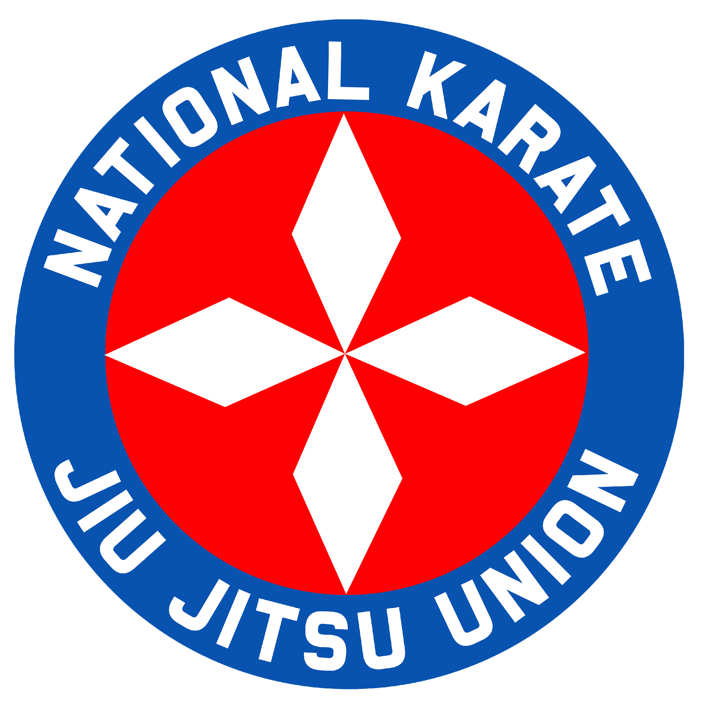
NKJU ® National Karate Jiu-Jitsu Union and National Karate jiu-jitsu Union Int. 2691 Worth County Line Road Albany, Georgia 31705 davisroyiv3@gmail.com
DECEMBER 2020 NKJU® Bulletin
NKJU ® & NKJUI® is a USPTO registered trademark owned by Roy D. Davis III. Any use of this name by any person, organization, company, or association with the marketing or sale of any products and services without the owner's permission violates the US Trade Mark Act.
All NKJU® & NKJUI® Bulletins are under Copyright and shall not be altered from their original form without the written permission from Kaicho Davis.
I think everyone can agree that 2020 will go down into the history books as one of the most unpredictable, chaotic, stressful, and challenging times since the Bubonic Plague. Only God knows what our future will be. But keep this in mind each day "When things get tough, the tough get going."
I hope everyone had a very Merry Christmas and a Happy New Year.
I have been in the martial arts for a long time, as I know many of you have. I have seen and experienced quite a lot over the years. I look at schools and organizations to see how they are ran and the problems they incur. The biggest problem that I have seen in most schools and organizations is when politics gets into the mix.
I was with Richard Baillargeon from 1973 to mid- 1987 when he was head of SKKU and during the inception of NKJU in 1974. Everything seemed to be running pretty well up until about the mid 80" s; then I began to notice a change. I started to see politics at work.
Side Note: Many who knew me in 1973 and forward had no idea of my age. This was to be a blessing since I was more mature than I looked. I was conscious of things that were going on within NKJU that others were not able to see. Anyone who has been employed by government agencies knows how politics works. I have seen things you would not believe. That is why I despise politics to this day.
Mr. B knew I could see the change. For this reason is why we become very close friends. We discussed some of these problems and someday soon, I will tell the story as I know it, with evidence to support the facts about the gradual decline of NKJU.
"LEGACY & HERITAGE"
Those who try to live off others' legacy without having trained directly under that person or has had little or no personal contact with that person are just being naive.
Naïve: "Is a person showing a lack of experience, wisdom, or judgment." To claim to know the legacy of an individual is to have been part of that person's life. Otherwise, it's just what you think you know and not what you know.
People should ask of anyone who claims a heritage or a legacy of an individual. Did you train Directly or In- Directly? (look up the definition of these two words.) And for how long, or were you just a weekend warrior, or a two or three-time training camp participant. Then let the facts speak for themselves.
Many organizations like NKJU of 1974 to 1989 start off with good intentions just to crash and burn due to politics. Many small things lead up to politics, but I can sum it up In one sentence. "Too many people want to be the Boss."
Many of you have seen these signs. Political activities within an organization that are aimed at improving someone's status or position and are typically considered to be devious or divisive. This is the definition of politics.
Many that I have talked to over the years has made this statement. I am tired of politics. Instead of training and improving our arts, politics becomes the topic of discussion.
Eventually, a person will get to the point when they say. "I am getting out of this, and I am going to do my own thing."
This attitude can be good or bad, depending on how you look at it. Doing your own thing creates FACTIONS. This, overtime, waters down the very thing you want to preserve. To preserve something means you must maintain (something) in its original or existing state. You cannot do this by yourself. There is power in unity, where everyone has the same core values and principals.
No one said the journey would be easy. If it were easy, everyone would do it.
If you genuinely love the arts as I do, you must search out those organizations. That has the same core values as you do. Now that you have a few years of experience under your belt, you know the right questions to ask a potential new organizational head.
As Kaicho of NKJU® I make it clear to anyone that is part of my org. I will not tolerate politics, bias, favoritism, or paper ranks. My legitimacy comes from Sensei Richard Baillargeon, Soshi Hugh Kelly, and Kaicho Butch Velez. Need I say more?
I also make it clear to anyone that affiliates with me that they are NOT to make any accusations of any kind on my behalf.
This specifically goes for my Fuku Kaicho and my Daihyo. What kind of leader would I be if I let others cover for me or fight my battles.
My Facebook site is closed. You must ask for a friend request. I intend to have only people who have integrity, high moral standards, and who will criticize themselves before they do others. Hypocrisy has no place in NKJU® or my life.
Any friend request I receive, I will ask you to call me By phone. By doing it this way it becomes more personnel.
This is my way of vetting. It's not perfect, but I am more accurate than not. I was asked some time ago if I thought I had anyone on my Facebook that may not be creditable. I will only say this. Keep your friends close and your enemies closer.
Hypocrisy: As defined by Merriam-Webster. The practice of claiming to have moral standards or beliefs to which one's behavior does not conform; pretense.
In my November bulletin, I mentioned to you that I was going to tell you how you can receive a Martial Arts Ph.D.
Ph.D is defined as the highest degree, a doctorate, awarded by a graduate school in a field of academic study, who has completed as least three years of graduate study. Note: To obtain a Ph.D. takes an average of 7.1 in an accredited university.
There is a firm that calls itself martialartsphd.com. They explain how You Can Receive A Legal Martial Arts Ph.D. without Any College Classes.
You can get ranks from Shodan to Judan. You can get titles from Renshi to Master, even Soke, and Grandmaster. Prices range from $497 up,
Scam or not? You make the decision. As for me, I know what I am. My credentials speak for themselves. Why would I want to get some degree from such a program? It's no more than a paper mill making money off people who want an easy way out and who's ego is beyond reproach.
There are other such sites on the domain that offer similar degrees. Now the McDojo Martial arts schools have competition.
It's the elite, McDojo Colleges and Universities. Who will prevail?
I know some who will say that martial arts are philosophies that should be recognized with a Ph.D., MA, or whatever.
Martial Arts Philosophy is like the many grains of sand on a beach. I have a philosophy about how I eat. “ Do I need a degree to prove I am a professional eater? “
Does martial arts philosophy fall into the realm of receiving degrees?
I would like to hear from some of you on your thoughts about this. Please email me. I will post it on my next bulletin. Only if you want it to be.
"Words for thought."
Every man should live with a purpose, defined by his morals.
If you wish to be removed from the email list, say so. Of, if you know someone who would be interested in the bulletin, forward it to them.
Kaicho Roy D. Davis III

